

**Quick Start Tutorials: How to load an Agent**

We assume that you obtained a correctly compiled agent (following our tutorial 'how to compile an agent'). Now you can add the agent in one of the following two ways: using the GUI or editing the XML file.

## Load the agent using the GUI

An agent can be easily added by going to the “Agents” tab in the “Components Window” (Figure 1). Next, pressing right click opens a popup with the option to add a new agent. The final step is to select the main class of your agent[1].

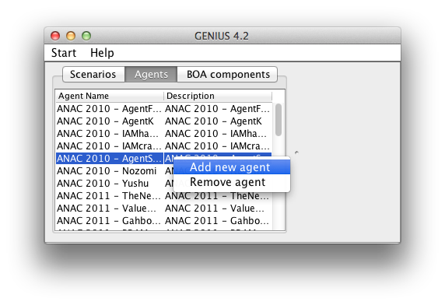

Figure . Adding an agent using the GUI.

## Load the agent by fixing the XML file

An alternative way is to directly edit the XML file that contains the known agents.

1. Open the agentrepository.xml file with your favourite text editor
2. Add a agentRepItem line as explained below
3. Save the agentrepository.xml file

When added, the agent will appear in the Agents list when you reopen the Genius application.

**The AgentRepItem**

An AgentRepItem is a line like this in the XML file

<agentRepItem

**description**="Simple Agent"

**classPath**="/Users/wouter/Desktop/genius/examplepackage/ExampleAgent.class"

**agentName**="Simple Agent"/>

The **description** is a general text description of the agent.

The **classPath** is an absolute path to the main Agent class in your package. Notice that there are also classPaths in the xml file that are not absolute paths, these are referring to agents inside the program and can not be used by you.

The agentName is a general text string giving the agent a name.

1. The main class is the class that extends the Genius negotiator.Agent class.